School Counseling Program Newsletter
Shandrai Silva, School Counselor | May 2017

Counselor Message  It’s fourth quarter, the last quarter of the 2016-17 school year. The school year has been filled with phenomenal learning opportunities and activities. Our Career Day on April 12th was a huge success. The feedback received on this event was very positive. Thank you.  As the school year winds down, the school counseling program will continue to facilitate individual, small group and classroom meetings with students  As we approach the end of the school year, please encourage students to keep working hard and to do their best always.  Four Ways to  Help Students Finish the School Year  - Gear Check- check supplies to make sure student still have the materials they need.  - Lead by Example- adopt a positive attitude and avoid speaking negatively about school. Encourage your kids to try their best, continue to set aside time to complete homework, and prioritize school attendance.  - Stick to the Routine- it's important to for children to continue to get a good night's rest through the end of the school year. Stick to the child's regular bedtime and continue to make time for homework and at-home reading.  - 1-2 Reasonable and Reachable Goals- Goals are a great way to keep students motivated and on-task towards the end of a school year  http://www.scholastic.com/parents/blogs/scholastic-parents-learning-toolkit/4-ways-to-help-your-student-finish-school-year-strong | Home of the Hawks      https://www.nami.org/  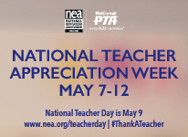  http://www.nea.org/grants/teacherday.html    http://www.nea.org/grants/31691.htm | Character Education  “We’re Soaring with Good Character”  ______________________________  The character trait of the month is Courage. Courage means doing the right thing even when others don't; following your conscience instead of the crowd; and attempting difficult things.  _________________________________  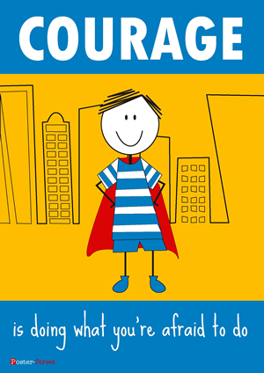  “Intelligence plus character- that is  the goal of true education.”  Dr. Martin L. King, Jr.    